

REQUEST FOR QUOTATION (RFQ) FOR APPOINTMENT OF A SERVICE PROVIDER FOR SPECIALISED EXHIBITION INSTALLATION INCLUDING PICTURE HANGING OF HERTIAGE OBJECTS AND ARTWORKS.
Reference Number | IZIKO R&E RFQ PICTURE HANGING-06-06-2026
Description | Iziko R&E Specialised Exhibition Installation and Hanging services.
Address | Iziko South African Museum, 25 Queen Victoria Street, Cape Town, 8001
Attention | Noleen Donson and Sikelwa Madlavu
Issue Date | 06 July 2026
Closing date for submission | 13 July 2026 @ 11am
Method of delivery | Quotes / Proposals, and accompanying documentation, must be emailed to scm@iziko.org.za, alewis@iziko.org.za
Technical enquiries | Andrea Lewis; alewis@iziko.org.za and Amy Sephton asephton@iziko.org.za
Name of Company
CSD Supplier Number (MA………...Number)

B-BBEE Status Level of Contribution

Quote Price (Incl. Vat)
Signature

- BACKGROUND

Iziko Museums of South Africa (Iziko) is a schedule 3A public entity and non-profit organisation, partly subsidised by the National Department of Sport, Arts & Culture (DSAC), bringing together 11 national museums and a Social History Centre situated in the Western Cape under a single governance and leadership structure. Iziko was established in terms of the Cultural Institutions Act, 1998 (Act No. 119 of 1998) and is required to comply with the Public Finance Management Act (PFMA), 1999 (Act No. 1 of 1999, as amended) and its concomitant Regulations. Iziko Museums deliver high-quality exhibitions across several sites.

- SCOPE OF SERVICES

Suitably qualified service providers* are invited to submit official quotations for specialised exhibition installation services, including picture, AV and collections hanging and mounting at Iziko Museums.
The service provider is requested to hang artworks, AV and other museum collections of various sizes, install complex artworks and objects, this includes the specialised design, fabrication and delivery of mounts for object/ artwork installations. Basic rigging work related to the installation, removal or movement of collection objects as required.

*Bidders must demonstrate experience with the following:

A. Hanging services for small, medium and large framed works
B. Installation of oversized or complex artworks or other objects, including basic rigging knowledge.
C. Specialised design, fabrication and delivery of mounts for object/ artwork installations.

- SCOPE OF WORK
Roll-out delivery is required as outlined below; allow for changes on discussion after appointment.

Matereality
Installation Site Iziko South African National Gallery (ISANG)

- ISANG will require assistance of the hanging services for five working days (9am to 4pm) for the Matereality show.
- The dates and times will be decided between the Iziko curator and the bidder on appointment. Bidders must be available between the dates of 1 August and 20 August.

- The exhibition will comprise a diverse range of artworks, including textiles, paintings on both conventional and unconventional materials, and installation-based works.
- While the majority of artworks will utilise the gallery's standard hanging system, several works require specialised mounting solutions, including:
  - Approximately ten (10) textile works requiring wooden dowels and cup hooks for secure display.
  - Four (4) artworks requiring custom wall-mounted brackets of approximately 600 mm in length to support the works.
  - Five (5) artworks requiring hanging best suited for FRAGILE wall ceramics.
  - Clear monofilament (fishing line) for suspended or discreetly mounted works.
  - Appropriate wall anchors, screws, hooks, fixings and mounting hardware necessary for the secure installation of all works.
  - Any additional brackets, supports, spacers or fixing solutions required to ensure the safe, stable and professional installation of artworks of varying sizes, weights and materials.
- Bidders must include the supply of all required materials, installation labour, and any fabrication necessary for the successful installation of these works.

IGC- Iziko Groot Constantia
Installation Site Iziko Groot Contantia Manor House (IGC)

- This installation will require assistance of the installation and hanging services for 20 working days (9am to 4pm). Broken Down into 2 separate installation blocks.
- The dates and times will be decided between the Iziko curator and the bidder on appointment. Bidders must be available between the dates of 21 July and 27 November.

- The exhibition will comprise a diverse range of museum objects, historic furnishings, interpretive elements, and display components within a house museum environment, requiring sensitive installation methods that protect the integrity of the historic building fabric and existing interiors. Due to the heritage significance of the site, drilling, permanent fixings, or alterations to walls and architectural features are not permitted. All installation methods must therefore utilise reversible and non-invasive solutions, including:

  - Fourteen (14) tension rod systems to fit between existing rafters or architectural features, providing secure hanging points without impacting the building structure. Max length 1.2m
  - Approximately twelve (12) textile interpretive elements hung requiring wooden dowels and cup hooks.
  - Two (2) artworks hung to using the tension rod system.
  - Fifty (50) objects crimped and discreetly secured using stainless-steel monofilament (trace wire).
  - Appropriate crimps hooks, fixings and mounting hardware necessary for the secure installation of all works.
  - Twenty (20) Low profile Stanchions with 100m of black stanchion rope. Stanchions Approx 45cm H x 25cm diameter weighted base with felt sheets to protect the historic floor.

- Bidders must include the supply of all required materials, installation labour, and any fabrication necessary for the successful installation of these works.

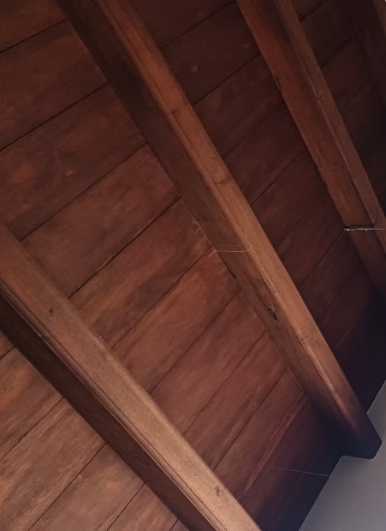
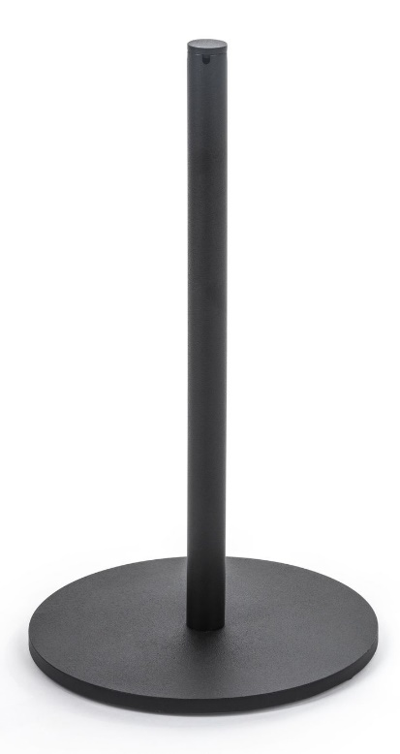

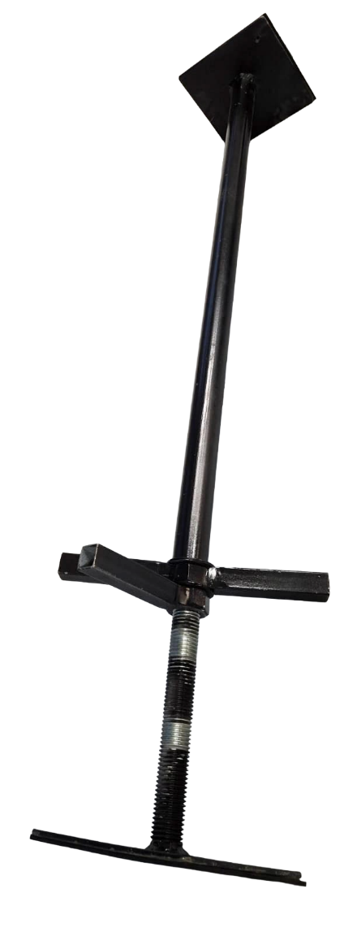

- OUTPUT/DELIVERABLES

Provision of specialised artwork, object installation, and hanging services for the specified exhibitions as outlined in the brief and annexures, including but not limited to:

Site Assessment, Planning and Coordination: The bidder must conduct site assessments where required, coordinate with Iziko’s relevant teams, review installation requirements, confirm access, equipment, safety considerations, and provide installation planning and OHS file, prior to commencement of work. All required site visits, coordination meetings, and travel related to installation planning and preparation must be included in the bidder’s cost.

Artwork and Object Handling, Hanging and Installation: Safe handling, positioning, hanging, installation, and securing of artworks, AV components, and museum collection objects of varying sizes and complexities. This includes objects requiring specialist handling and installation methods. All transport to site and associated installation costs required to complete the installation must be included in the bidder’s cost, including any required access equipment, installation equipment, tools, and materials necessary to complete the work.

Travel and Accommodation Costs: All travel costs, including airfare, accommodation, and related expenses necessary to complete site visits, coordination meetings, and installation activities must be included in the bidder’s quotation.

Installation Completion: Completion of all hanging and installation works to the required exhibition standard, ensuring artworks, objects, and AV components are securely installed, visually aligned, and presented in accordance with approved exhibition requirements.

- PRICING

Price is an important factor as it ensures optimum value for money. A cost schedule detailing, inclusive of VAT, any disbursements, travel, production costs and overtime, if applicable, etc. must be provided in the table 1 below:

Please layout your quote as per the table provided below.

No. | Service Description | QTY | Cost ex. VAT | Total Amount (Incl. VAT)
Materiality
A | Installation labour of minimum of 2-3 people (full working day 9am to 4pm) | 5 days
B | Cost for all specialised mounting solutions outlined in brief | As per brief
C | Travel and Accommodation Costs (if applicable) | 5 consecutive days on site
Groot Contantia
D | Installation labour of minimum of 2-3 people  (full working day 9am to 4pm) | 20 days
E | Travel and Accommodation Costs (if applicable) | 10 consecutive days on site
F | Travel and Accommodation Costs (if applicable) | 10 consecutive days on site
 | Cost for all specific mounting solutions outlined in brief as follows:
G | Tension rods | 14
J | Low profile Stanchions | 20
K | Black stanchion rope. | 100m
M | All other mounting hardware needed as indicated in the brief (such as the stainless-steel monofilament trace wire and crimps). | As per brief
 | Total | R |  | R

Pricing schedule above and formal quotation must include all applicable costs and there can be no variation after award has been made.

Quotations must be valid for a minimum period of sixty (60) days calculated from the closing date of the request to quote.

- EVALUATION PROCESS & CRITERIA

Qualifying responses will be evaluated on the Price and Preference Points.

5.1 Evaluation of Quotation
The contract shall be awarded at the sole and absolute discretion of Iziko. Iziko hereby represents that it is not obliged to award this quotation to any bidder. Iziko is entitled to retract this quotation at any time as from the date of issue or reduce deliverables.

5.2 Preferential Points
Bidders must comply with all the mandatory requirements outlined below, to be able to proceed further to price and preference evaluation. Proposals will be evaluated on the 80/20 preference points scoring system: that is, 80% of the points awarded will be based on price, as indicated in the table below; and 20% of the points awarded will be based on specific goals, allocated as indicated in the table below:

 | Specific goals allocated points | Price
Total maximum points | 20 | 80

Service Providers must submit all documents as outlined in Table 3: Compliance Documents.
SBD documents to be completed are supplied below.

Table 3: Compliance Documents

1 | Central Supplier Database Report – with supplier number and company details ( )  and (Compliant) Tax Status Verification Pin together with tax registration number.
2 | Detailed pricing structure: A cost schedule detailing the full cost breakdown, inclusive of VAT, any disbursement, and escalations, if applicable, etc. for the entire duration of the proposed contract must be provided. A separate quote can accompany this as an additional document.
3 | A Valid B-BBEE Certificate or Sworn Affidavit to determine the Service provider’s status level.
4 | SBD 6.1 - Preference points claim form
5 | SBD 4 – Bidders disclosure.
6 | Completed Request to quote submission (all pages of this file filled in where applicable and submitted)
7 | The bidder must provide verifiable evidence demonstrating technical capability to independently plan and execute complex museum-standard exhibition installations.  Evidence may include reference letters, completion certificates, contracts, or contactable client references from galleries, museums, cultural institutions, or similar organisations. Documentation must clearly demonstrate successful completion of projects that included all of the following within the past five years:  - Large-scale artworks (floor, wall, or spatial installations);  - Delicate or suspended works requiring precision handling and/or rigging coordination;  - AV installations, including projectors, screens, media players, and associated technical integration; and  - Fabrication and installation of specialised mounts, brackets, and non-standard fabrication solutions.
8 | The bidder must provide verifiable evidence demonstrating six (6) or more years' experience in the handling and installing high-value, irreplaceable heritage objects and artworks.  Evidence may include a company profile, portfolio of completed projects with images and brief descriptions, reference letters, completion certificates, contracts, purchase orders, invoices, or other documentation demonstrating relevant experience. The submission must include a minimum of two contactable client references from reputable commercial galleries, museums, cultural institutions, or similar organisations that can verify the bidder's experience and performance.

Note: Failure to supply any of the compliance documents stipulated may lead to the quote not being considered.

- PREFERENCE POINTS CLAIM

SBD 6.1 Preference Points Claim form in terms of the Preferential Procurement Regulations of 2022. The points are allocated as follows:

Table 4: Preference Point System
Description |  | Points Allocated
 | Price | 80 Points
 | Specific Goals | 20 Points
- FORMAL CONTRACT

a) The proposal and appended documentation read together form the basis for an agreement to be negotiated and concluded in a formal contract between Iziko and the preferred Service Provider.

b) A mere offer and acceptance shall not constitute a formal contract of any nature for any purpose between Iziko and the preferred Service Provider/s.

- GENERAL PRINCIPLES

a) The lowest or only quotation received will not necessarily be accepted.

b) Iziko and its Council reserve the right to accept or reject any quotation in response to the Request to
Quote and to withdraw its decision to seek the provision of these services at any time.

- Consent

The Bidder, by signing this document, hereby consents to the use of their personal information described herein and confirms that:

- they have obtained all the necessary consent from their shareholders/directors or counterparts, including the consent for Iziko to receive and process such personal information.
- Failure to provide the information will result in the objectives of the RFQ not being achieved, with the Bidder being disqualified.
- The Bidder voluntarily submits this bid/document containing personal information, for the purposes of the RFQ.

Iziko is committed to protecting the Bidder’s privacy and recognises that it needs to comply with statutory requirements in collecting, processing, and distributing personal information. The Constitution of the Republic of South Africa provides that everyone has the right to privacy and the Protection of Personal Information Act 4 of 2013 (“POPI”) includes the right to protection against unlawful collection, retention, dissemination, and use of personal information. In terms of section 18 of POPI, if personal information is collected Iziko, as responsible party, must take reasonably practical steps to ensure that the data subject is made aware of the information being collected.

9.1 Declaration
The undersigned, who warrants that he / she is duly authorized to do so on behalf of the enterprise:
i) confirms that neither the name of the enterprise or the name of any partner, manager, director or other person, who wholly or partly exercises, or may exercise, control over the enterprise appears on the Register of Tender Defaulters established in terms of the Prevention and Combating of Corrupt Activities Act of 2004;
ii) confirms that no partner, member, director or other person, who wholly or partly exercises, or may exercise, control over the enterprise appears, has within the last five years been convicted of fraud or corruption.
iii) confirms that I / we are not associated, linked or involved with any other tendering entities submitting tender offers and have no other relationship with any of the tenderers or those responsible for compiling the scope of work that could cause or be interpreted as a conflict of interest and;
iv) confirms that the contents of this questionnaire/forms (SBD 4, & 6.1) are within my personal knowledge and are to the best of my belief both true and correct
v) accept that, in addition to cancellation of the contract, action may be taken against me should the Declaration prove to be false.
- In terms of Preferential Procurement Regulation 11 and section 2(1) (f) of the Preferential Procurement Policy Framework Act, the IZIKO may consider the following objective criteria in the bid award:
- The risk of fruitless and wasteful expenditure to the IZIKO.
- The risk of an abnormally low bid.
- The risk of a material irregularity.
- The IZIKO reserves the right not to consider bids from Bidders who are currently in litigation with the IZIKO; and
- The IZIKO further reserves the right not to award this tender to any Bidder based on the proven poor record of accomplishment of the Bidder in previous projects within the IZIKO and the referee submitted by the Bidder.

Signed |  | Date
Name |  | Position
Enterprise name

Please note that if the supporting documentation is not provided then the submission will be classified as non-responsive.
- Disqualification
Please note that if a bid document is not filled in correctly or completely, or complied with the specification, or is delivered/send after the bid closing date and time, or the supplier is not registered on the CSD or supplier has a non-compliant tax status, then unfortunately that bidder maybe disqualified. Please return this document with the supporting documents.

2. Bid Document Submission
Emailed tender documents will be accepted. However, the onus is on the tenderer to ensure that complete email documents have been received by the IZIKO by the due date and time.
Please note that any alterations to the tender document other than filling in the tenderer’s details and tender price will automatically disqualify the tenderer.

BIDDER’S DISCLOSURE (SBD 4)

- PURPOSE OF THE FORM (SBD 4)

Any person (natural or juristic) may make an offer or offers in terms of this invitation to bid. In line with the principles of transparency, accountability, impartiality, and ethics as enshrined in the Constitution of the Republic of South Africa and further expressed in various pieces of legislation, it is required for the bidder to make this declaration in respect of the details required hereunder.

Where a person/s are listed in the Register for Tender Defaulters and / or the List of Restricted Suppliers, that person will automatically be disqualified from the bid process.

- Bidder’s declaration

2.1 Is the bidder, or any of its directors / trustees / shareholders / members / partners or any person having a controlling interest in the enterprise, employed by the state? YES/NO
(please select or underline the applicable position highlighted in bold).

2.1.1 If so, furnish particulars of the names, individual identity numbers, and, if applicable, state employee numbers of sole proprietor/ directors / trustees / shareholders / members/ partners or any person having a controlling interest in the enterprise, in table below. (please select or underline the applicable position highlighted in bold).
Full Name | Identity Number | Name of State institution
2.2 Do you, or any person connected with the bidder, have a relationship with any person who is employed by the procuring institution? YES/NO
2.2.1 If so, furnish particulars:
……………………………………………………………………………………
……………………………………………………………………………………

2.3 Does the bidder or any of its directors / trustees / shareholders / members / partners or any person having a controlling interest in the enterprise have any interest in any other related enterprise whether or not they are bidding for this contract? YES/NO (please select or underline the applicable position highlighted in bold).

    - If so, furnish particulars:
…………………………………………………………………………….
…………………………………………………………………………….

- DECLARATION

I,………………………………………………the……………………………undersigned, (name)……………………………………………………………………. in submitting the accompanying bid, do hereby make the following statements that I certify to be true and complete in every respect:

3.1 I have read and I understand the contents of this disclosure;

3.2 I understand that the accompanying bid will be disqualified if this disclosure is found not to be true and complete in every respect;

  - The bidder has arrived at the accompanying bid independently from, and without consultation, communication, agreement or arrangement with any competitor. However, communication between partners in a joint venture or consortium will not be construed as collusive bidding.

3.4 In addition, there have been no consultations, communications, agreements or arrangements with any competitor regarding the quality, quantity, specifications, prices, including methods, factors or formulas used to calculate prices, market allocation, the intention or decision to submit or not to submit the bid, bidding with the intention not to win the bid and conditions or delivery particulars of the products or services to which this bid invitation relates.

3.4 The terms of the accompanying bid have not been, and will not be, disclosed by the bidder, directly or indirectly, to any competitor, prior to the date and time of the official bid opening or of the awarding of the contract.

3.5 There have been no consultations, communications, agreements or arrangements made by the bidder with any official of the procuring institution in relation to this procurement process prior to and during the bidding process except to provide clarification on the bid submitted where so required by the institution; and the bidder was not involved in the drafting of the specifications or terms of reference for this bid.

  - I am aware that, in addition and without prejudice to any other remedy provided to combat any restrictive practices related to bids and contracts, bids that are suspicious will be reported to the Competition Commission for investigation and possible imposition of administrative penalties in terms of section 59 of the Competition Act No 89 of 1998 and or may be reported to the National Prosecuting Authority (NPA) for criminal investigation and or may be restricted from conducting business with the public sector for a period not exceeding ten (10) years in terms of the Prevention and Combating of Corrupt Activities Act No 12 of 2004 or any other applicable legislation.

I CERTIFY THAT THE INFORMATION FURNISHED IN PARAGRAPHS 1, 2 and 3 ABOVE IS CORRECT.
I ACCEPT THAT THE STATE MAY REJECT THE BID OR ACT AGAINST ME IN TERMS OF PARAGRAPH 6 OF PFMA SCM INSTRUCTION 03 OF 2021/22 ON PREVENTING AND COMBATING ABUSE IN THE SUPPLY CHAIN MANAGEMENT SYSTEM SHOULD THIS DECLARATION PROVE TO BE FALSE.

……………………………… ..……………………………………………
Signature Date

……………………………… ………………………………………………
Position Name of bidder (Company Name)
(SBD 6.1)

PREFERENCE POINTS CLAIM FORM IN TERMS OF THE PREFERENTIAL PROCUREMENT REGULATIONS 2022

This preference form must form part of all tenders invited. It contains general information and serves as a claim form for preference points for specific goals.

NB: BEFORE COMPLETING THIS FORM, TENDERERS MUST STUDY THE GENERAL CONDITIONS, DEFINITIONS AND DIRECTIVES APPLICABLE IN RESPECT OF THE TENDER AND PREFERENTIAL PROCUREMENT REGULATIONS, 2022

- GENERAL CONDITIONS
  - The following preference point systems are applicable to invitations to tender:
- the 80/20 system for requirements with a Rand value of up to R50 000 000 (all applicable taxes included); and
- the 90/10 system for requirements with a Rand value above R50 000 000 (all applicable taxes included).

  - To be completed by the organ of state
The applicable preference point system for this tender is the 80/20 preference point system.

  - Points for this tender (even in the case of a tender for income-generating contracts) shall be awarded for:
- Price; and
- Specific Goals.

  - To be completed by the organ of state:
The maximum points for this tender are allocated as follows:
 | POINTS
PRICE | 80
SPECIFIC GOALS | 20
Total points for Price and SPECIFIC GOALS | 100

  - Failure on the part of a tenderer to submit proof or documentation required in terms of this tender to claim points for specific goals with the tender, will be interpreted to mean that preference points for specific goals are not claimed.

  - The organ of state reserves the right to require of a tenderer, either before a tender is adjudicated or at any time subsequently, to substantiate any claim in regard to preferences, in any manner required by the organ of state.

- DEFINITIONS
- “tender” means a written offer in the form determined by an organ of state in response to an invitation to provide goods or services through price quotations, competitive tendering process or any other method envisaged in legislation;
- “price” means an amount of money tendered for goods or services, and includes all applicable taxes less all unconditional discounts;
- “rand value” means the total estimated value of a contract in Rand, calculated at the time of bid invitation, and includes all applicable taxes;
- “tender for income-generating contracts” means a written offer in the form determined by an organ of state in response to an invitation for the origination of income-generating contracts through any method envisaged in legislation that will result in a legal agreement between the organ of state and a third party that produces revenue for the organ of state, and includes, but is not limited to, leasing and disposal of assets and concession contracts, excluding direct sales and disposal of assets through public auctions; and
- “the Act” means the Preferential Procurement Policy Framework Act, 2000 (Act No. 5 of 2000).
- FORMULAE FOR PROCUREMENT OF GOODS AND SERVICES

  - POINTS AWARDED FOR PRICE

3.1.1 THE 80/20 OR 90/10 PREFERENCE POINT SYSTEMS
A maximum of 80 or 90 points is allocated for price on the following basis:

80/20 or 90/10

$Ps=80\left(1-\frac{Pt-P }{P }\right)$ or $Ps=90\left(1-\frac{Pt-P }{P }\right)$
Where
Ps = Points scored for price of tender under consideration
Pt = Price of tender under consideration
Pmin = Price of lowest acceptable tender

  - FORMULAE FOR DISPOSAL OR LEASING OF STATE ASSETS AND INCOME GENERATING PROCUREMENT

    - POINTS AWARDED FOR PRICE

A maximum of 80 or 90 points is allocated for price on the following basis:

80/20 or 90/10

$Ps=80\left(1+\frac{Pt-P }{P }\right)$ or $Ps=90\left(1+\frac{Pt-P }{Pmax}\right)$

Where
Ps = Points scored for price of tender under consideration
Pt = Price of tender under consideration
Pmax = Price of highest acceptable tender

- POINTS AWARDED FOR SPECIFIC GOALS

  - In terms of Regulation 4(2); 5(2); 6(2) and 7(2) of the Preferential Procurement Regulations, preference points must be awarded for specific goals stated in the tender. For the purposes of this tender the tenderer will be allocated points based on the goals stated in table 1 below as may be supported by proof/ documentation stated in the conditions of this tender:
  - In cases where organs of state intend to use Regulation 3(2) of the Regulations, which states that, if it is unclear whether the 80/20 or 90/10 preference point system applies, an organ of state must, in the tender documents, stipulate in the case of—
- an invitation for tender for income-generating contracts, that either the 80/20 or 90/10 preference point system will apply and that the highest acceptable tender will be used to determine the applicable preference point system; or

- any other invitation for tender, that either the 80/20 or 90/10 preference point system will apply and that the lowest acceptable tender will be used to determine the applicable preference point system,
then the organ of state must indicate the points allocated for specific goals for both the 90/10 and 80/20 preference point system.

Table 1: Specific goals for the tender and points claimed are indicated per the table below.
(Note to organs of state: Where either the 90/10 or 80/20 preference point system is applicable, corresponding points must also be indicated as such.
Note to tenderers: The tenderer must indicate how they claim points for each preference point system.)
The specific goals allocated points in terms of this tender | Evidence | Number of points  allocated  (80/20 system)  (To be completed by the organ of state) | Number of points claimed (80/20 system)  (To be completed by the tenderer)
Persons, or categories of persons, historically disadvantaged- (HDI) by unfair dis crimination on the basis of | - Proof of B-BBEE certificate;  - Company Registration Certification  - Identification Documentation.  - CSD report
Race: Black persons (ownership)*
50% or more black ownership = 20 points

Less than 50% black ownership = 10 points
0% black ownership = 0 points

DECLARATION WITH REGARD TO COMPANY/FIRM

  - Name of company/firm…………………………………………………………………….
  - Company registration number: …………………………………………………………...
  - TYPE OF COMPANY/ FIRM
• Partnership/Joint Venture / Consortium
• One-person business/sole propriety
• Close corporation
• Public Company
• Personal Liability Company
• (Pty) Limited
• Non-Profit Company
• State Owned Company
[Tick applicable box]

  - I, the undersigned, who is duly authorised to do so on behalf of the company/firm, certify that the points claimed, based on the specific goals as advised in the tender, qualifies the company/ firm for the preference(s) shown and I acknowledge that:
- The information furnished is true and correct;
- The preference points claimed are in accordance with the General Conditions as indicated in paragraph 1 of this form;
- In the event of a contract being awarded as a result of points claimed as shown in paragraphs 1.4 and 4.2, the contractor may be required to furnish documentary proof to the satisfaction of the organ of state that the claims are correct;
- If the specific goals have been claimed or obtained on a fraudulent basis or any of the conditions of contract have not been fulfilled, the organ of state may, in addition to any other remedy it may have –

  - disqualify the person from the tendering process;
  - recover costs, losses or damages it has incurred or suffered as a result of that person’s conduct;
  - cancel the contract and claim any damages which it has suffered as a result of having to make less favourable arrangements due to such cancellation;
  - recommend that the tenderer or contractor, its shareholders and directors, or only the shareholders and directors who acted on a fraudulent basis, be restricted from obtaining business from any organ of state for a period not exceeding 10 years, after the audi alteram partem (hear the other side) rule has been applied; and
  - forward the matter for criminal prosecution, if deemed necessary

the power, by one person or a group of persons holding the majority of the equity of an enterprise, alternatively, the person/s having the deciding vote or power to influence or to direct the course and decisions of the enterprise.
Joint venture or Consortium means an association of persons for the purpose of combining their expertise, property, capital, efforts, skill and knowledge in an activity for the execution of a contract.

